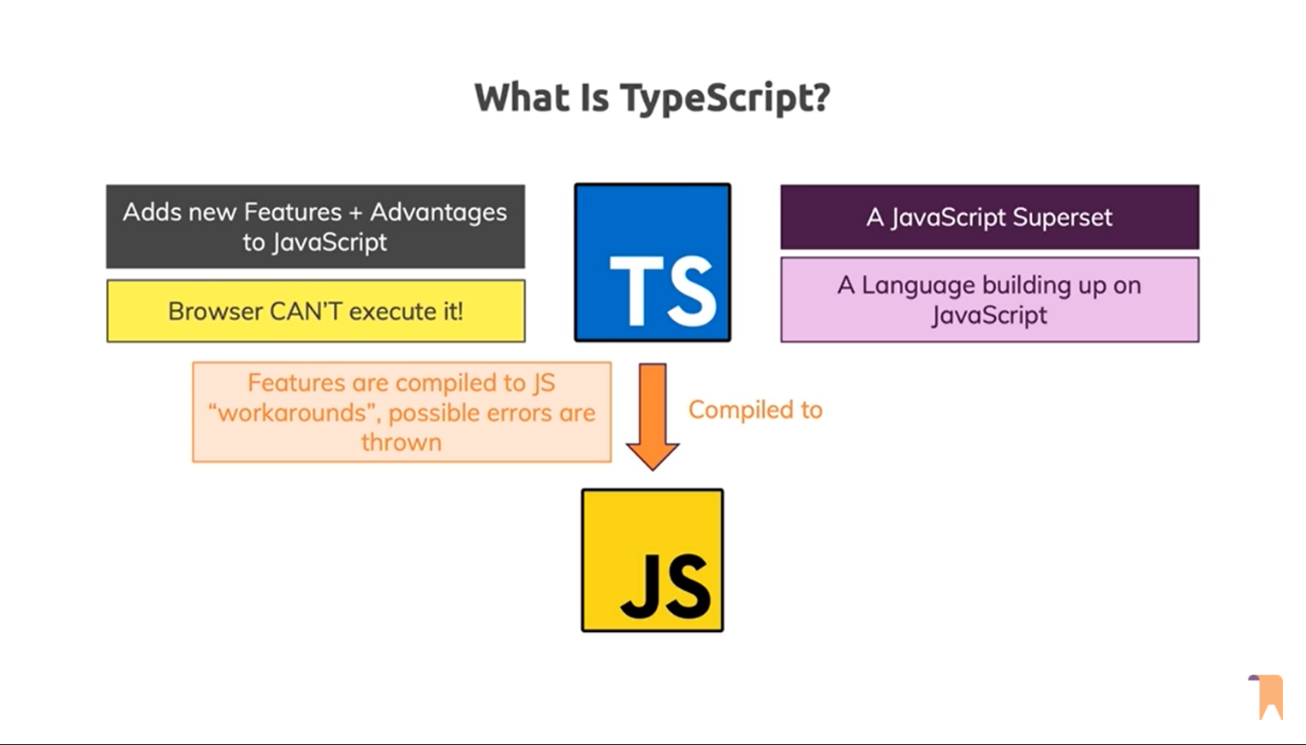

TypeScript is Typed JavaScript. TypeScript adds types to JavaScript

Nor node

.ts & .tsx is the extension for TypeScript

***TypeScript is a programming language and a powerful compiler.***

TSC (TypeScript Compiler) is used to compile TypeScript file(.ts) transpile to pure JS(.js).

**Pros**:

More Robust | Easily spot Bugs | Predictability | Readability | Popular

**Cons**:

More code to write | more to learn | required compilation | not true static typing

**Type Annotation**

let name: string = 'John';

let age: number = 25;

let active: boolean = true;

**compile**: tsc <TS_Filename.ts> | tsc <TS_Filename>

To continuous **monitor** the changes tsc --watch <TS_Filename.ts>

tsc --init for configuration file

document.getElementByID(‘’)!;

! make sure it always returns a value and never be the null.

There are three main primitives in JavaScript and TypeScript.

1. boolean
2. number
3. string

**Type Assignment**

When creating a variable, there are two main ways TypeScript assigns a type:

Explicit => let firstName: string = "Dylan";

Implicit => let firstName = "Dylan";

Note: Having TypeScript "guess" the type of a value is called **infer**.